CSE 535: Project 2 Report

Please utilize this report to showcase the results after executing your code for each of the ten specified test cases. Remember to FLUSH the entire system state before processing each set of transactions (this means that all data maintained on both the server and clients must be cleared completely. Each set of transactions represents a separate scenario, and the system performs a complete reset before processing the next set). Each page of the report will focus on a single test case. Ensure that the results presented here align with those shown in your recording and during the demo. If your system encounters a crash or fails to produce results for any of the items, please make a note of it clearly. For any functions that do not return a value, simply leave that section blank.
Please finish the report before your demo time and submit it using the provided link on Brightspace

Test case 1

a) PrintDB()

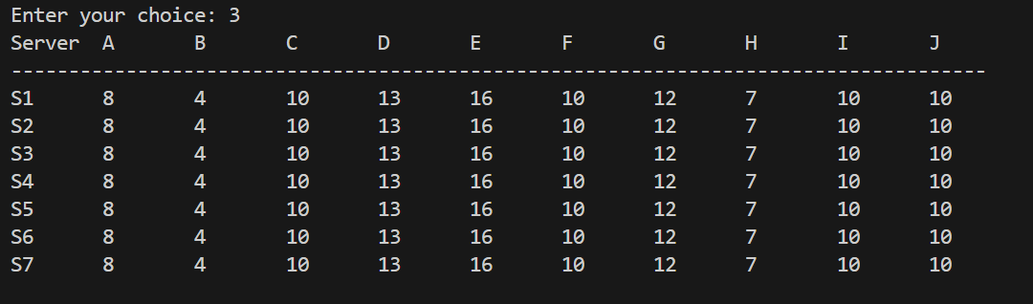

b) PrintStatus()
 | S1 | S2 | S3 | S4 | S5 | S6 | S7
PrintStatus(1) | E | E | E | E | E | E | E
PrintStatus(2) | E | E | E | E | E | E | E
PrintStatus(3) | E | E | E | E | E | E | E
PrintStatus(4) | E | E | E | E | E | E | E

c) PrintView() empty []

d) Performance() :
e)PrintLog(S2)

Test case 2

a) PrintDB()

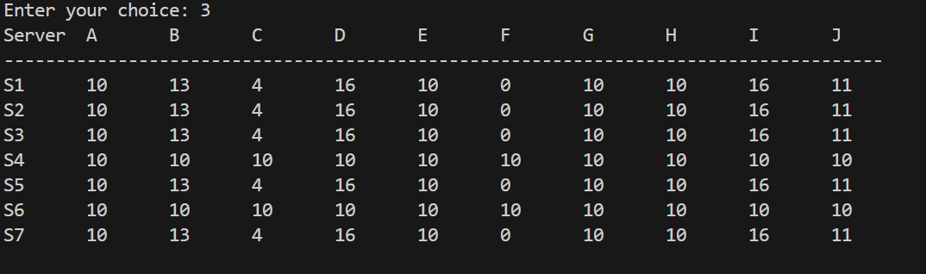

b) PrintStatus()
 | S1 | S2 | S3 | S4 | S5 | S6 | S7
PrintStatus(1) | E | E | E | PP | E | PP | E
PrintStatus(2) | E | E | E | PP | E | PP | E
PrintStatus(3) | E | E | E | PP | E | PP | E
PrintStatus(4) | E | E | E | PP | E | PP | E
PrintStatus(5) | E | E | E | PP | E | PP | E

c) PrintView() EMPTY [ ]

d) Performance()
e)PrintLog(S4)

Test case 3

a) PrintDB()

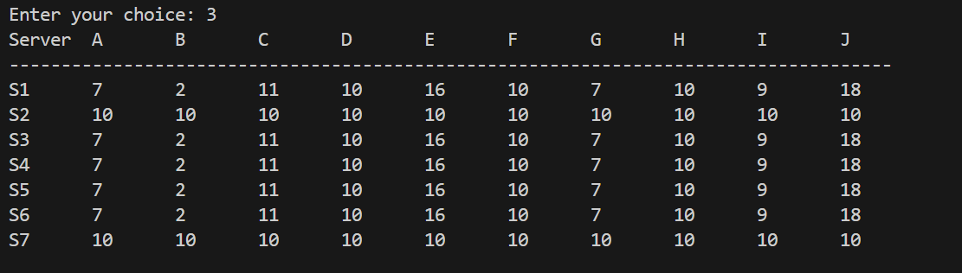

b) PrintStatus()
 | S1 | S2 | S3 | S4 | S5 | S6 | S7
PrintStatus(1) | E | X | E | E | E | E | X
PrintStatus(2) | E | X | E | E | E | E | X
PrintStatus(3) | E | X | E | E | E | E | X
PrintStatus(4) | E | X | E | E | E | E | X
PrintStatus(5) | E | X | E | E | E | E | X

c) PrintView() EMPTY [ ]

d) Performance()

e) PringLog(S1)

Test case 4

a) PrintDB()

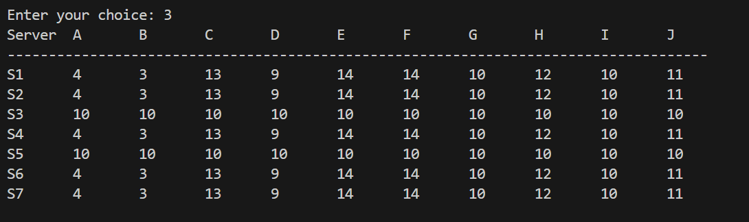

b) PrintStatus()
 | S1 | S2 | S3 | S4 | S5 | S6 | S7
PrintStatus(1) | E | E | PP | E | X | E | E
PrintStatus(2) | E | E | PP | E | X | E | E
PrintStatus(3) | E | E | PP | E | X | E | E
PrintStatus(4) | E | E | PP | E | X | E | E
PrintStatus(5) | E | E | PP | E | X | E | E
PrintStatus(6) | E | E | PP | E | X | E | E
PrintStatus(7) | E | E | PP | E | X | E | E

c) PrintView() EMPTY [ ]

d) Performance()

Test case 5

a) PrintDB()

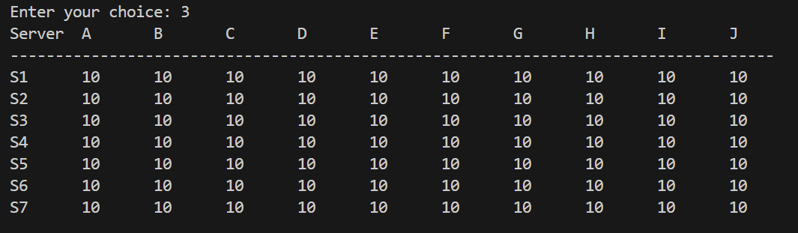

b) PrintStatus()
 | S1 | S2 | S3 | S4 | S5 | S6 | S7
PrintStatus(1) | E | E | E | E | E | PP | E
PrintStatus(2) | E | E | E | E | E | PP | E
PrintStatus(3) | E | E | E | E | E | PP | E
PrintStatus(4) | E | E | E | E | E | PP | E
PrintStatus(5) | E | E | E | E | E | PP | E
PrintStatus(6) | E | E | E | E | E | PP | E
PrintStatus(7) | E | E | E | E | E | PP | E
PrintStatus(8) | E | E | E | E | E | PP | E
PrintStatus(9) | E | E | E | E | E | PP | E
PrintStatus(10) | E | E | E | E | E | PP | E

c) PrintView()
EMPTY [ ]

d) Performance()

Test case 6

a) PrintDB()

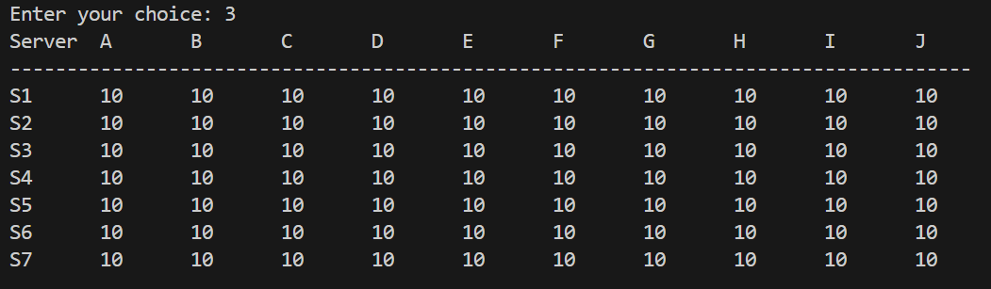

b) PrintStatus()
 | S1 | S2 | S3 | S4 | S5 | S6 | S7
PrintStatus(1) | PP | PP | PP | PP | PP | PP | PP
PrintStatus(2) | PP | PP | PP | PP | PP | PP | PP
PrintStatus(3) | PP | PP | PP | PP | PP | PP | PP
PrintStatus(4) | PP | PP | PP | PP | PP | PP | PP
PrintStatus(5) | PP | PP | PP | PP | PP | PP | PP
PrintStatus(6) | PP | PP | PP | PP | PP | PP | PP

c) PrintView() EMPTY [ ]

d) Performance()

e) PringLog(S1)

Test case 7

a) PrintDB()

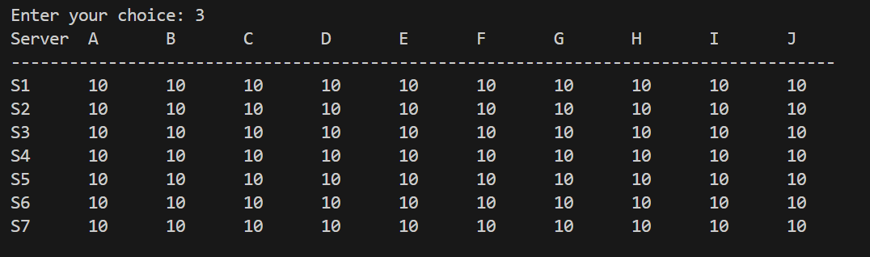

b) PrintStatus()
 | S1 | S2 | S3 | S4 | S5 | S6 | S7
PrintStatus(1) | PP | PP | PP | PP | PP | X | X
PrintStatus(2) | PP | PP | PP | PP | PP | X | X
PrintStatus(3) | PP | PP | PP | PP | PP | X | X
PrintStatus(4) | PP | PP | PP | PP | PP | X | X
PrintStatus(5) | PP | PP | PP | PP | PP | X | X
PrintStatus(6) | PP | PP | PP | PP | PP | X | X

c) PrintView() EMPTY – [ ]

d) Performance()

Test case 8

a) PrintDB()

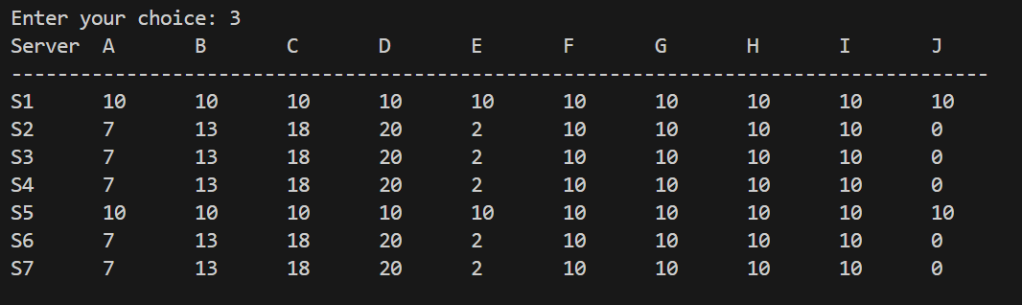

b) PrintStatus()
 | S1 | S2 | S3 | S4 | S5 | S6 | S7
PrintStatus(1) | PP | E | E | E | PP | E | E
PrintStatus(2) | PP | E | E | E | PP | E | E
PrintStatus(3) | PP | E | E | E | PP | E | E

c) PrintView()

d) Performance()

e) PringLog(S1)

Test case 9

a) PrintDB()

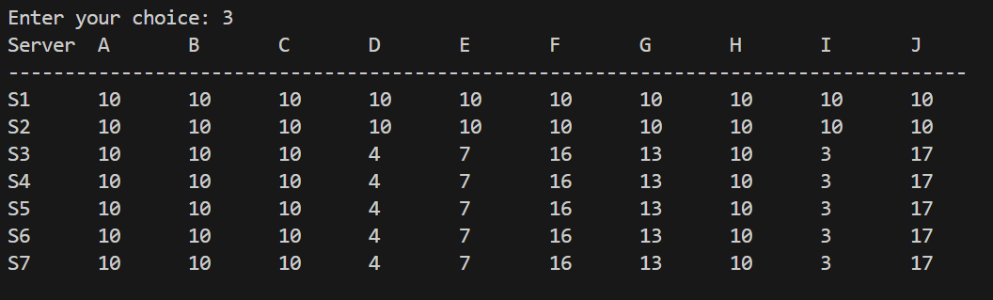

b) PrintStatus()
 | S1 | S2 | S3 | S4 | S5 | S6 | S7
PrintStatus(1) | PP | PP | E | E | E | E | E
PrintStatus(2) | PP | PP | E | E | E | E | E
PrintStatus(3) | PP | PP | E | E | E | E | E

c) PrintView()

d) Performance()

e) PringLog(S1)

Test case 10

a) PrintDB()



b) PrintStatus()
 | S1 | S2 | S3 | S4 | S5 | S6 | S7
PrintStatus(1) | E | E | E | E | E | PP | E
PrintStatus(20) | E | E | E | E | E | PP | E
PrintStatus(49) | E | E | E | E | E | PP | E
PrintStatus(50) | E | E | E | E | E | PP | E

c) PrintView() EMPTY – [ ]

d) Performance()

